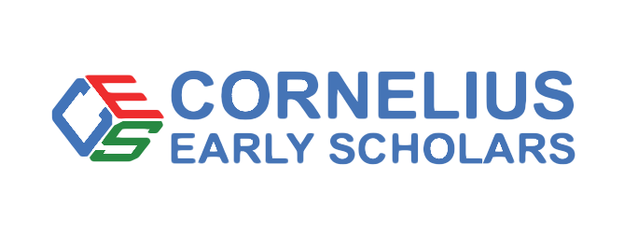
Cornelius Early Scholars is a nonprofit 501 (c) (3) scholarship Christian preschool that provides children with the first steps in their early childhood education. Our mission is to ensure every child receives a quality education in a nurturing and safe environment. We believe that every child deserves the opportunity to reach their full potential, and we strive to provide the tools and resources necessary to make it happen.

Donor Full Name:
Donor Address:
City, State
Zip Code
Email address
Phone:
Would you prefer to keep your donation private or may be list your name on our website:
Please mail check to Cornelius Early Scholars at 19708 Charles Towne Lane, Cornelius, NC 28031
Our Commitment to Our Donors
We will not sell, share or trade our donors’ names or personal information with any other entity, nor send mailings to our donors on behalf of other organizations.
This policy applies to all information received by Cornelius Early Scholars, both online and offline, on any Platform (‘Platform’, includes the Cornelius Early Scholars website and mobile applications), as well as any electronic, written, or oral communications.
To the extent any donations are processed through a third-party service provider, our donors’ information will only be used for purposes necessary to process the donation.

